BCU BEAM Mode Setting
1.Run BCU to get a setting and save to a file "1.txt"
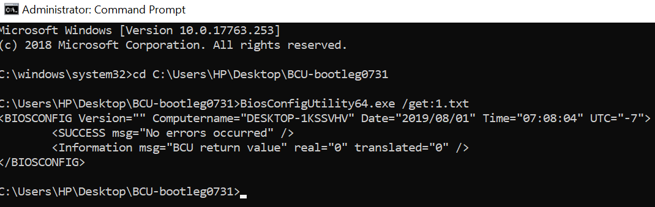
2.Modify BCU setting file
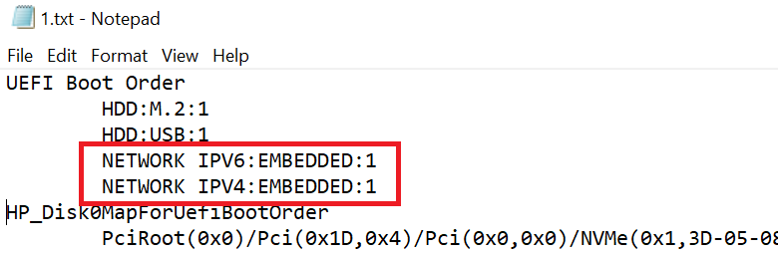
3.BCU new parameters as below, type "BiosConfigUtility64.exe /?" to get parameters list.
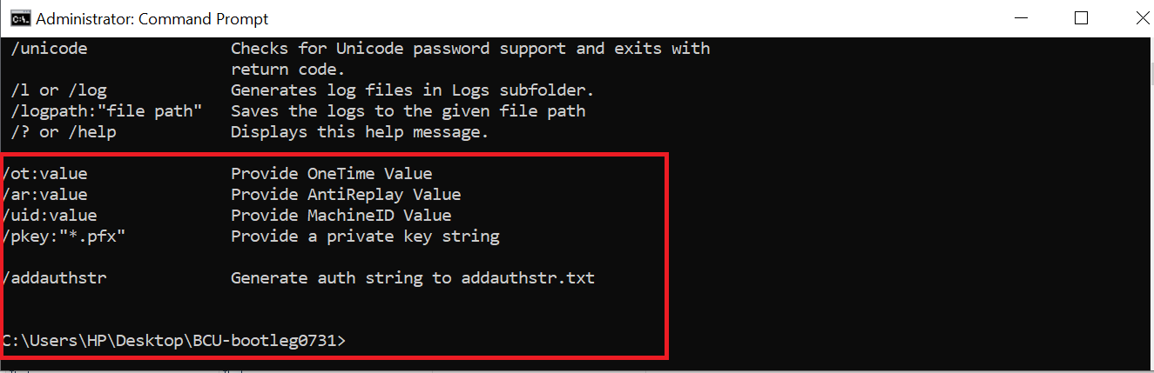

4.Run BCU with parameter “addauthstr” to save AuthString to a file “BCU-AuthString.txt”.
Mode1. Input all parameters as below
BiosConfigUtility64.exe /set:1.txt /or:0 /ar:0 /pkey:signing_key.pfx /addauthstr
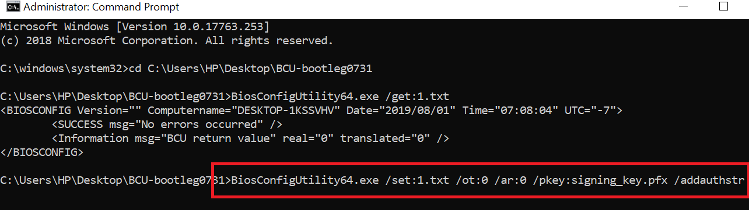
Mode2. Using BeamSetting.txt to instead of some parameters.
user also can ignore some parameters and put it to a profile file with name “BeamSetting.txt”.
BiosConfigUtility64.exe /set:1.txt /ot:0 /ar:0 /uid:xxxx /Pkey:xxx /addauthstr
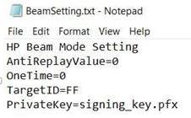

5.BCU generate auth string file as below.
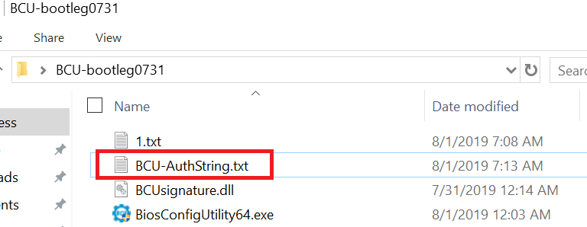

7.BCU-AuthString file include encripted Auth strings.
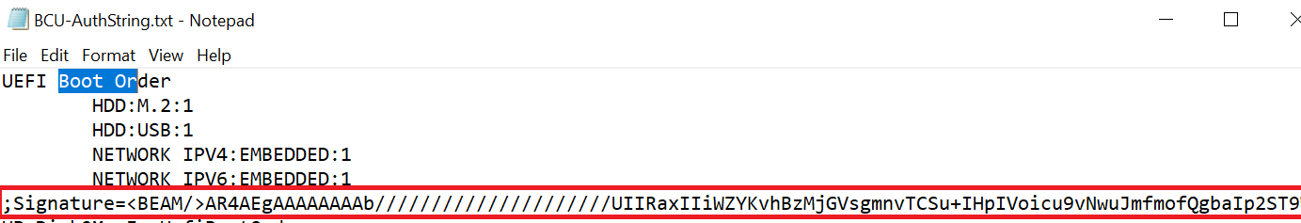

8.Run BCU to set BCU-AuthString.txt , no need to input others parameters.
BCU get "Signature strings" and send it to Bios as below.
